Fragmented
Artist: Angelo Pesce

- Self-Isolation Photoshoot
- Creative Photography + Bespoke artistic software
- Large prints might be made and sold for charity

Software creates a digital grain, inspired by photographic film emulsions, but not trying to replicate the same process.

Images evoke the theme of isolation, distance.

Examples of end results, processing stock images through the software:

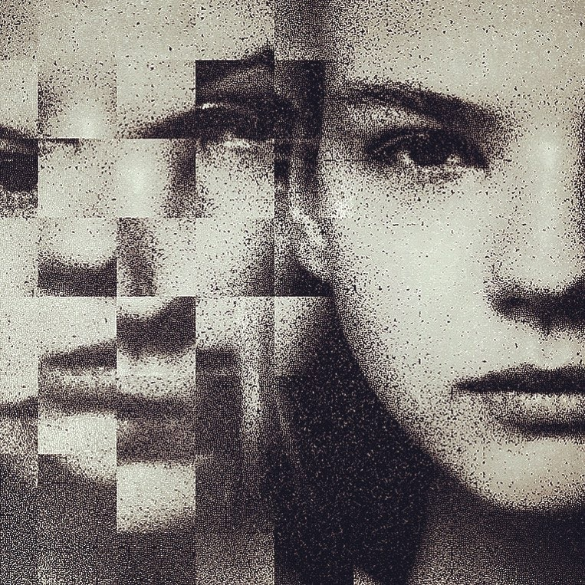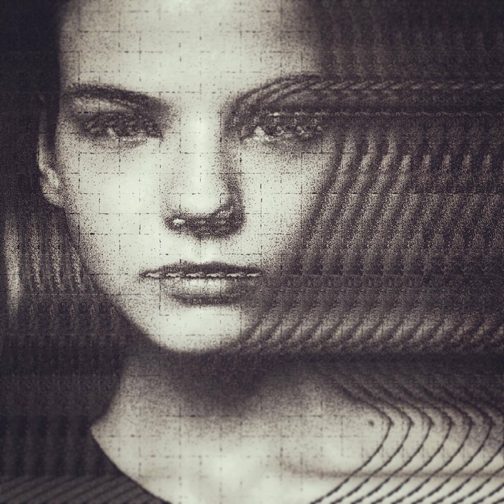

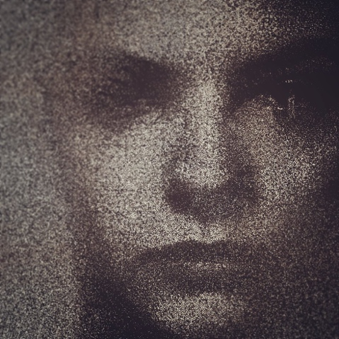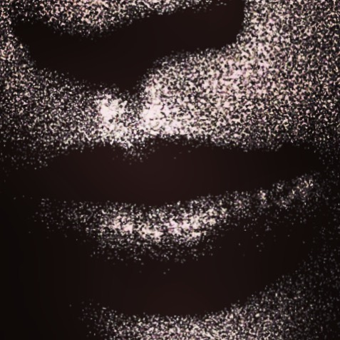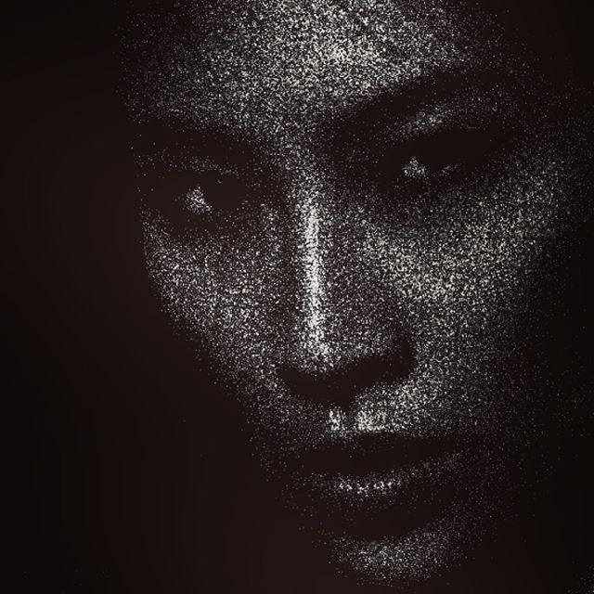

Guidelines:

Simple, polaroid style, flat background, preferably darker than skintone

No need for elaborate makeup

